Machine learning final Assignment
Nicholas Horvat
Student id:22336024

1.1: For my training datasets, I created a python function that creates lines of 1-2 random operands with randomised integers, they are only added to the dataset if the output is an integer between -99 and +99(inclusive)
For training, only 1 dataset is used, with a mix of all of the options
For testing, specific operands and lengths are used, this allows us to get a better insight into where the models are performing well
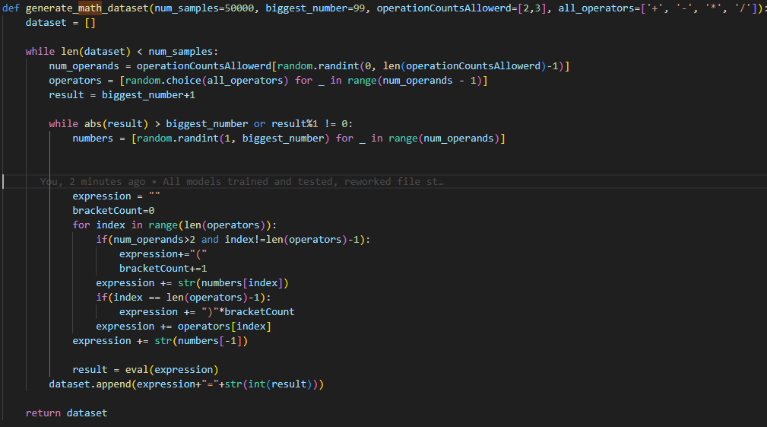

1.2. The most appropriate evaluation metric I decided was to test how often each model would get the correct answer, this was done by testing each model against 100 examples of each option, and recording the results as such.

1.3: For the test I created 5 different models
Default: Original GPT parameters (n_embd=384, n_head=6, n_layer=6)
Faster Learning Rate: lr=1e-3, if this performed well, it could vastly reduce the training time of the model
Larger Model: n_embd=512, n_head=8, n_layer=8
Smaller Block Size: block_size=128
Smaller Model: n_embd=128, n_head=4, n_layer=4

1.4: Each of these performed differently.
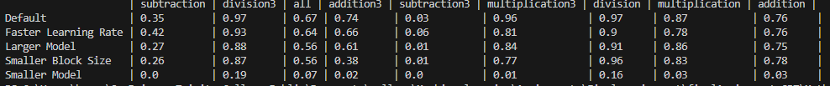

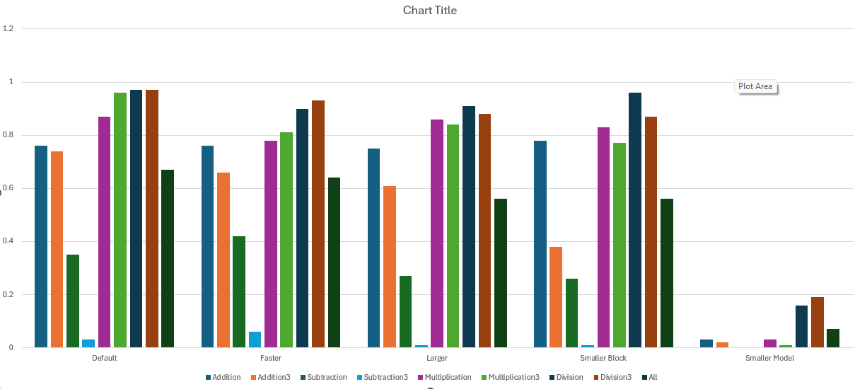
Interestingly, the default model seems to be the best performing.
The larger model was a close second. This suggests that the larger model may have suffered from overfitting, while the default model was within the sweet-spot.
The smaller block model also performed slightly worse, disproving my idea that small arithmetic functions had no need for large block sizes
The faster learning model was worse than the default, despite executing the same number of steps in training, showing that it is not an efficient alternative.
The Smaller Model performed significantly worse than all of the other models, showing that even for something as simple as basic arithmetic, a somewhat complex model is needed.
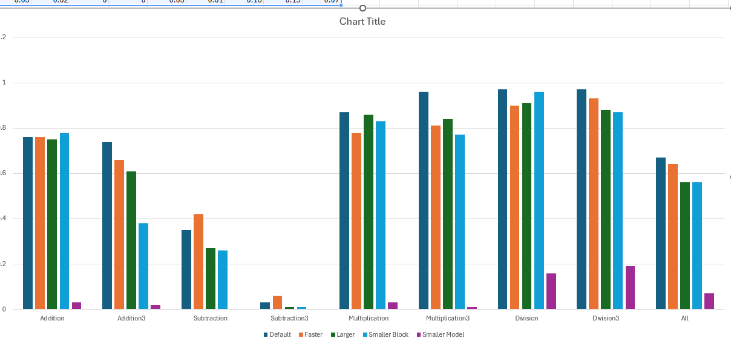
From the data we can see that addition and subtraction is surprisingly difficult for the models, my best guess for the cause of this is that the addition and subtraction lends itself to bigger numbers. 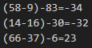 vs 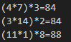
Another interesting detail is that(with the exception of subtraction) the dropoff of a operand to its 3integer alternative seems to be quite small. With most dropping off by less than 5%.
My assumption for why subtraction3 performed so poorly, is due to the fact that the numbers
The most important test was the “all” test, which had a mix of all operand combinations, similar to the training data. This seemed to be about average of all of the other operations which is what was expected.

